**SMART WATER MANAGEMENT**

**INTRODUCTION:**

Smart water management is a modern and innovative approach to managing one of our most precious resources – water. In an era characterized by rapid urbanization, population growth, and increasing environmental concerns, the traditional methods of water management are being revolutionized by technology and data-driven solutions. Smart water management leverages cutting-edge technologies, such as sensors, data analytics, and automation, to optimize the use of water resources, enhance water quality, reduce waste, and ensure the long-term sustainability of our water supply.

This approach is not limited to just the water utility sector but extends to a wide range of industries, including agriculture, manufacturing, and residential consumption. It integrates real-time monitoring and control of water infrastructure, efficient distribution, and proactive maintenance, allowing for a more intelligent, responsive, and sustainable use of water.

In this age of digital transformation, smart water management is vital for addressing the challenges associated with water scarcity, pollution, and climate change. It empowers water utilities, businesses, and communities to make informed decisions, reduce costs, and minimize environmental impacts while providing safe and reliable access to clean water.

This introduction provides a glimpse into the transformative world of smart water management, where technology and data converge to ensure the efficient and sustainable use of our planet's most essential resource.

**DESCRIPTION:**

Smart water management is a comprehensive approach to efficiently and sustainably manage water resources using advanced technologies and data-driven strategies. The project objectives of smart water management typically include:

**1. Resource Optimization:** Optimize the use of water resources by reducing waste and ensuring efficient distribution. This involves monitoring water sources, consumption, and identifying opportunities for conservation.

**2. Leak Detection and Prevention:** Implement systems to detect and prevent leaks in water distribution networks. This helps in reducing water loss and minimizing the costs associated with repairing infrastructure.

**3. Real-time Monitoring:** Use sensors and data analytics to monitor water quality, flow rates, pressure, and other critical parameters in real-time. This allows for quick response to issues and better control of water supply.

**4. Demand Forecasting:** Predict future water demand patterns based on historical data and environmental factors. This helps utilities plan for adequate supply and infrastructure investments.

**5. Water Quality Management:** Ensure the delivery of safe and clean water by monitoring and controlling water quality parameters. Smart systems can automatically adjust treatment processes and notify authorities in case of contamination events.

**6. Asset Management:** Keep track of water infrastructure assets, such as pipes, pumps, and treatment facilities, to schedule maintenance and replacement proactively, minimizing downtime and costs.

**7. Customer Engagement:** Enhance communication with water consumers by providing information about water use, billing, and conservation. Smart water management systems can encourage customers to use water more efficiently.

**8. Sustainability and Conservation:** Promote sustainable water use and conservation practices by raising awareness and implementing incentives for reducing water consumption.

**9. Disaster Preparedness:** Develop plans and systems for managing water resources during emergencies such as floods, droughts, or contamination events. Smart water management can help ensure a swift response and recovery.

**10. Data Analytics and Predictive Models:** Utilize data analytics and predictive modeling to make informed decisions about water management, including optimizing treatment processes, resource allocation, and infrastructure planning.

**11. Regulatory Compliance:** Ensure compliance with water quality and environmental regulations by providing accurate data and reports to relevant authorities.

**12. Cost Reduction:** Reduce operational costs associated with water treatment, distribution, and maintenance through the efficient use of resources and proactive maintenance practices.

**13. Integration of Renewable Energy:** Explore opportunities to integrate renewable energy sources into water treatment and distribution processes to reduce energy costs and environmental impact.

**14. Collaboration and Partnerships:** Foster collaboration among government agencies, utilities, researchers, and technology providers to advance smart water management solutions and share best practices.

Overall, the primary goal of smart water management projects is to ensure the sustainable and efficient use of water resources, reduce waste, improve service quality, and respond effectively to the challenges of urbanization, climate change, and population growth. These objectives contribute to the conservation of this essential resource and the long-term resilience of water supply systems.

**IOT DEVICES:**

**1. pH Sensors:** These sensors measure the acidity or alkalinity of water, helping to assess water quality and suitability for various purposes, including drinking water and industrial processes.

**2. Turbidity Sensors:** Turbidity sensors measure the cloudiness or haziness of water caused by the presence of suspended particles. This parameter is important for assessing water quality.

**3. Conductivity Sensors:** Conductivity sensors measure the water's ability to conduct an electrical current, which can indicate the concentration of dissolved solids in the water.

**4. Dissolved Oxygen Sensors:** These sensors measure the amount of oxygen dissolved in water. Oxygen levels are crucial for aquatic life and can indicate water quality.

**5. Chlorine Sensors:** Chlorine sensors measure the concentration of chlorine, a common disinfectant, in water. These sensors are used to ensure that water treatment processes are effective.

**6. Temperature Sensors:** Temperature sensors monitor water temperature, which can affect water quality and the efficiency of treatment processes.

**7. Pressure Sensors:** Pressure sensors measure water pressure within the distribution system. Variations in pressure can indicate leaks or other system issues.

**8. Flow Sensors:** Flow sensors measure the rate at which water flows through a pipe or channel. They are important for monitoring water distribution and detecting anomalies.

**9. Level Sensors:** Level sensors monitor the water level in tanks, reservoirs, and wells. They help control water storage and distribution.

**10. Optical Sensors:** Optical sensors are used for various purposes, including detecting specific contaminants or measuring the color of water.

**11. Ultrasonic Sensors:** Ultrasonic sensors can measure water level and depth in tanks, open bodies of water, and rivers.

**12. Pressure Transducers:** Pressure transducers convert pressure readings into electrical signals and are used in various applications, including water pressure monitoring.

**13. Water Quality Multi-Parameter Sensors:** These sensors can measure multiple parameters simultaneously, such as pH, turbidity, conductivity, and temperature, providing a comprehensive view of water quality.

**14. GPS Sensors:** In some cases, GPS sensors may be used to determine the geographic coordinates of sensor locations and integrate data with GIS systems.

**15. Leak Detection Sensors:** These sensors can detect pressure changes, flow irregularities, or acoustic anomalies in the water distribution system, indicating potential leaks.

**16. Remote Monitoring and Control Sensors:** Sensors that allow for remote monitoring and control of pumps, valves, and other equipment in the distribution system.

**DEVICE SETUP:**

Setting up devices for a smart water management system involves deploying a combination of hardware and software components to monitor and control the water distribution system efficiently. Here is an overview of the device setup process:

**1. Sensor Deployment:** Install a network of water quality and quantity sensors at strategic points in the water distribution system. These sensors should be carefully selected to match the project's objectives and requirements.

**2. IoT Devices:** Deploy IoT devices near the sensors to collect and transmit data. These IoT devices are responsible for gathering data from sensors and forwarding it to a central data collection point.

**3. Communication Infrastructure:** Set up the communication infrastructure that connects IoT devices to the central server. Common communication methods include Wi-Fi, cellular networks, Low-Power Wide-Area Networks (LPWAN), or other wireless technologies.

**4. Data Protocols:** Implement data transmission protocols such as MQTT, HTTP, or other industry-standard protocols to transmit sensor data to the central server securely.

**5. Data Concentrators (RTUs):** In larger systems, consider using Remote Terminal Units (RTUs) at various locations to process and aggregate data from sensors. RTUs can provide local control and act as data concentrators.

**6. Central Data Collection Point:** Establish a central data collection point or server where all the incoming sensor data will be aggregated and processed. Ensure that this server has the capacity to store and manage large volumes of data.

**7. Data Processing and Analytics:** Develop data processing and analytics modules to clean, preprocess, and analyze the incoming data. This may involve the use of data analysis tools and algorithms to derive insights from the data.

**8. Real-Time Monitoring and Control:** Create real-time monitoring and control capabilities to visualize the incoming sensor data. Dashboards and alerting systems can help operators and stakeholders monitor water quality and system performance.

**9. Alerts and Notifications:** Implement an alerting system that sends notifications (e.g., SMS, email) to operators and stakeholders when predefined thresholds are exceeded, such as water quality issues, leaks, or equipment failures.

**10. Security Measures:** Implement robust cybersecurity measures to secure the IoT devices, communication channels, and data storage systems. This is crucial to protect data integrity and ensure the infrastructure's resilience against cyber threats.

**11. Remote Access and Control:** Enable remote access and control of IoT devices, allowing for remote diagnostics, firmware updates, and equipment control from a central location.

**12. Data Storage and Backup:** Implement data storage and backup solutions to ensure data integrity and prevent data loss. Utilize a robust database system to store historical data.

**13. Power Supply:** Ensure a reliable power supply for both sensors and IoT devices. This may involve a combination of mains power, battery backups, and solar power for remote locations.

**14. Testing and Calibration:** Test the sensors and IoT devices to ensure they accurately measure data. Regular calibration and maintenance may be necessary.

**15. Compliance and Regulations:** Ensure that the device setup complies with relevant regulations and standards for water quality monitoring and data transmission.

**16. Redundancy:** Implement redundancy in both sensors and IoT devices to ensure data continuity in case of sensor or device failures.

**17. Data Validation:** Implement data validation checks to ensure the accuracy and consistency of incoming data.

**18. Maintenance Plan:** Develop a maintenance plan that includes routine sensor calibration, device updates, and system health checks.

A well-designed device setup is a crucial part of a smart water management system, as it allows for the collection of accurate and reliable data, enabling effective water quality monitoring, distribution, and system management

**PLATFORM DEVELOPMENT:**

**1. Define Project Objectives:** Clearly define the goals and objectives of your smart water management platform. Consider the specific needs and requirements of your project, such as water quality monitoring, leak detection, or demand forecasting.

**2. Hardware and Sensor Integration:** Integrate the data collected from sensors and IoT devices into the platform. Ensure that data is accurately transmitted to the central data collection point and stored securely.

**3. Data Collection and Storage:** Set up a robust data collection and storage infrastructure. Utilize databases to store and manage the collected data. Ensure data security and privacy.

**4. Data Processing and Analytics:** Develop data processing and analytics modules to clean, preprocess, and analyze the incoming data. This includes the use of machine learning and AI algorithms for predictive modeling and anomaly detection.

**5. User Interface and Dashboards:** Create user-friendly web-based dashboards and mobile applications. These interfaces should provide real-time data visualization, alerts, and historical trend analysis.

**6. Automation and Control:** Implement automation algorithms to control water treatment processes, valve operations, and pressure regulation. This may involve closed-loop control systems.

**7. Alerts and Notifications:** Set up an alerting system to notify operators and stakeholders when specific events or conditions, such as water quality issues or leaks, occur.

**8. Remote Monitoring and Control:** Enable remote monitoring and control capabilities that allow operators to adjust equipment settings and diagnose issues from a central location.

**9. Security and Privacy:** Implement robust cybersecurity measures to protect data and the infrastructure from cyber threats. Comply with data privacy regulations and standards.

**10. Integration with GIS:** Integrate the platform with Geographic Information Systems (GIS) to provide spatial context and facilitate geospatial analysis.

**11. Regulatory Compliance:** Ensure the platform complies with water quality and environmental regulations. Generate compliance reports and data for regulatory authorities.

**12. Testing and Validation:** Rigorously test the platform to ensure its performance, accuracy, and reliability under various conditions, including stress testing and simulated emergency scenarios.

**13. Training and Capacity Building:** Provide training to personnel and stakeholders on using the platform effectively. Ensure that operators and decision-makers can interpret data and respond to alerts.

**14. Continuous Improvement:** Establish a feedback loop for continuous improvement, allowing for the adaptation of the system to changing needs, technological advancements, and regulatory requirements.

**15. Collaboration and Integration:** Foster collaboration with government agencies, utilities, researchers, and technology providers to advance smart water management solutions and share best practices.

**CODE IMPLEMENTATION:**

import random

import time

import pandas as pd

# Simulated pH sensor reading

def read_ph_sensor():

return random.uniform(6.5, 8.5)

# Simulated turbidity sensor reading

def read_turbidity_sensor():

return random.uniform(0.1, 1.0)

# Simulated flow rate sensor reading

def read_flow_rate_sensor():

return random.uniform(5, 15)

# Data storage (simulated database)

data_store = pd.DataFrame(columns=['Timestamp', 'pH', 'Turbidity', 'FlowRate'])

# Simulated real-time monitoring

def real_time_sensor_monitoring():

while True:

timestamp = pd.Timestamp.now()

pH_value = read_ph_sensor()

turbidity_value = read_turbidity_sensor()

flow_rate_value = read_flow_rate_sensor()

data = {

'Timestamp': timestamp,

'pH': pH_value,

'Turbidity': turbidity_value,

'FlowRate': flow_rate_value,

}

data_store = data_store.append(data, ignore_index=True)

print(f"Timestamp: {timestamp}")

print(f"pH: {pH_value}")

print(f"Turbidity: {turbidity_value}")

print(f"Flow Rate: {flow_rate_value}\n")

time.sleep(60) # Simulate data collection every minute

if __name__ == "__main__":

real_time_sensor_monitoring()

**DIAGRAM:**

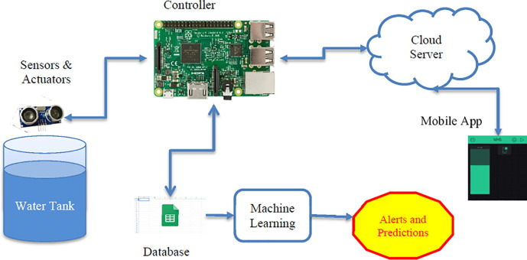

**SCHEMATIC DIAGRAM:**

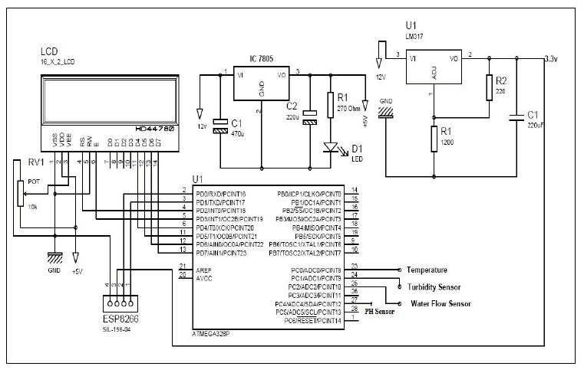

**CIRCUIT DIAGRAM:**

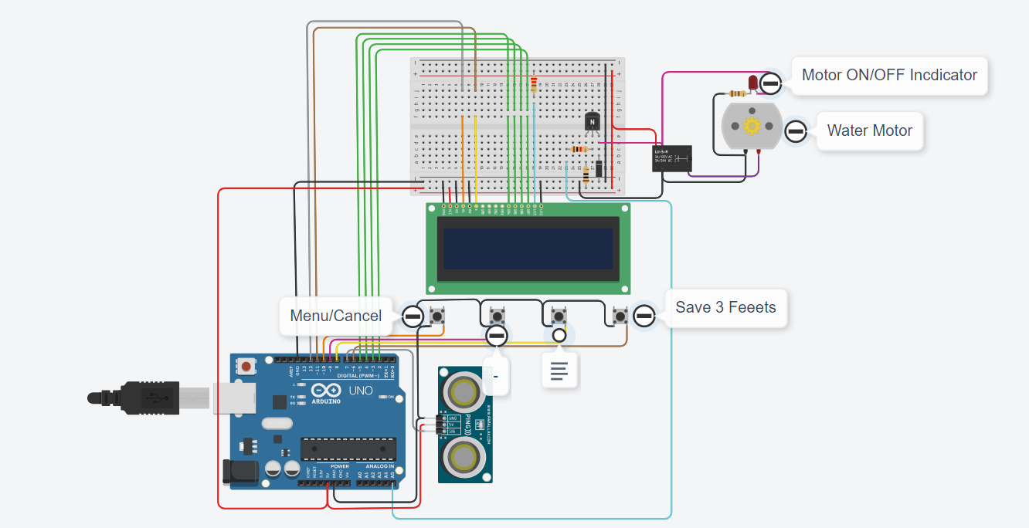

**SCREENSHOT:**

**DATA SHARING:**

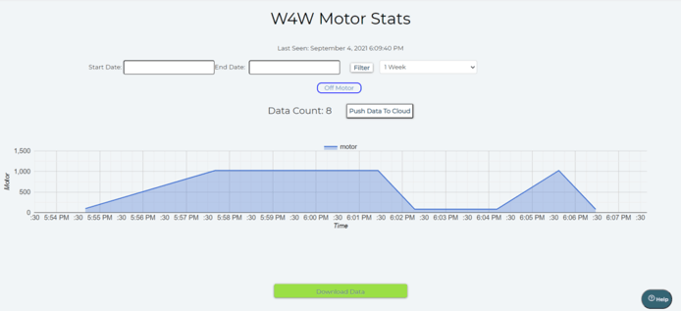

**PROJECT IN DETAIL:**

1. **Project Objectives and Planning:** Needs Assessment: Identify the specific goals and objectives of the project, considering the unique requirements of the region, organization, or community. Stakeholder Engagement: Involve key stakeholders, such as water utility operators, government agencies, and consumers, in project planning to ensure alignment with their needs.

**2. Sensor Selection and Deployment:** Sensor Types: Choose appropriate sensors to monitor key parameters, such as pH, turbidity, flow rate, pressure, chlorine levels, temperature, and more. Sensor deployment: Install sensors at strategic points in the water distribution system, including water sources, treatment plants, reservoirs, pumping stations, and along the distribution network.

**3. IoT Device Setup:** IoT Hardware: Deploy IoT devices to collect data from sensors and transmit it to a central data collection point. Choose suitable communication methods, such as Wi-Fi, cellular, or Low-Power Wide-Area Networks (LPWAN). Data Protocols: Implement data transmission protocols, such as MQTT or HTTP, to securely send sensor data to the central server.

**4. Central Data Collection and Storage:** Set up a centralized data collection point or server capable of storing and managing the vast amount of data generated by sensors. Use reliable databases to store and manage historical data.

**5. Data Processing and Analytics:** Develop data processing and analytics modules to clean, preprocess, and analyze the incoming data. Utilize data analysis tools and machine learning algorithms for predictive modeling and anomaly detection.

**6. User Interface and Dashboards:** Create user-friendly web-based dashboards and mobile applications for various stakeholders, providing real-time data visualization, alerts, and historical trend analysis.

**7. Automation and Control:** Implement automation algorithms to control water treatment processes, valve operations, pressure regulation, and other system components. Develop closed-loop control systems that respond to real-time sensor data.

**8. Alerts and Notifications:** Set up an alerting system that sends notifications to operators and stakeholders when specific conditions, such as water quality issues or equipment failures, are detected.

**9. Remote Monitoring and Control:** Enable remote monitoring and control capabilities that allow operators to adjust equipment settings, perform diagnostics, and receive system alerts from a central location.

**10. Security and Privacy:** Implement robust cybersecurity measures to protect data and the infrastructure from cyber threats. Ensure compliance with data privacy regulations and standards.

**11. Integration with GIS:** Integrate the platform with Geographic Information Systems (GIS) to provide spatial context and enable better decision-making based on location data.

**12. Regulatory Compliance:** Ensure that the platform complies with water quality and environmental regulations. Generate compliance reports and data for regulatory authorities.

**13. Testing and Validation:** Conduct thorough testing to verify the platform's performance, accuracy, and reliability in real-world conditions. Test under various scenarios, including stress testing and simulated emergency situations.

**14. Training and Capacity Building:** Provide training for personnel and stakeholders to effectively use the platform and make informed decisions based on the data and alerts.

**15. Continuous Improvement:** Establish a feedback loop for continuous improvement, considering the evolving needs and challenges of the water management system. Adapt the platform to changing requirements and emerging technologies.